Persistence Model (Entity for DB)

📝Definition
# Source: AI Source: Provided by: [Data Path: Persons Table -> ID Column: 1, Name_En Column: Motasem Essam] -> From: [ChatGPT] on [1/23/2026]
The Persistence Model represents how data is stored in a database.
It is often called a Database Entity or Entity for DB, and it maps domain objects to database tables.
👉 Focused on storage structure, not business logic

🔑 Key Characteristics
# Source: AI Source: Provided by: [Data Path: Persons Table -> ID Column: 1, Name_En Column: Motasem Essam] -> From: [ChatGPT] on [1/23/2026]
- ✅ Maps domain objects to tables
- ✅ Contains fields/columns matching the database
- ✅ May include ORM annotations (JPA, Hibernate, Entity Framework, etc.)
- ❌ Should not contain business logic

🧱 Example – JPA Entity in Java
# Source: AI Source: Provided by: [Data Path: Persons Table -> ID Column: 1, Name_En Column: Motasem Essam] -> From: [ChatGPT] on [1/23/2026]
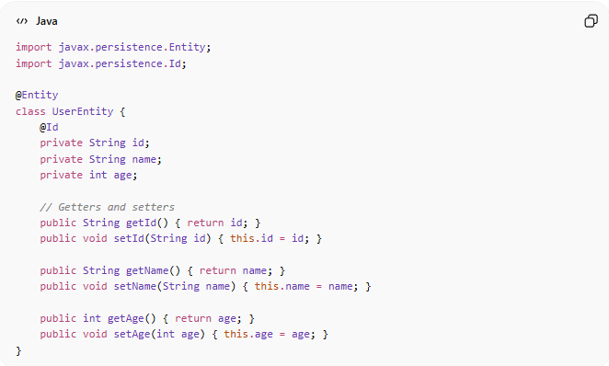
import javax.persistence.Entity;
import javax.persistence.Id;

@Entity
class UserEntity {
@Id
private String id;
private String name;
private int age;

// Getters and setters
public String getId() { return id; }
public void setId(String id) { this.id = id; }

public String getName() { return name; }
public void setName(String name) { this.name = name; }

public int getAge() { return age; }
public void setAge(int age) { this.age = age; }
}

🔄 Flow
# Source: AI Source: Provided by: [Data Path: Persons Table -> ID Column: 1, Name_En Column: Motasem Essam] -> From: [ChatGPT] on [1/23/2026]
Domain Model (Entity) ↔ Mapper ↔ Persistence Model (DB Entity) ↔ Database
- Domain Entity → contains business logic
- Persistence Model → contains only DB structure
- Mapper → converts between Domain Entity and Persistence Model

❌ Bad Example
# Source: AI Source: Provided by: [Data Path: Persons Table -> ID Column: 1, Name_En Column: Motasem Essam] -> From: [ChatGPT] on [1/23/2026]
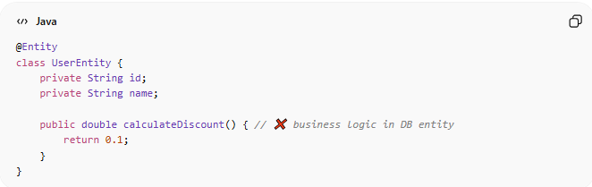
@Entity
class UserEntity {
private String id;
private String name;

public double calculateDiscount() { // ❌ business logic in DB entity
return 0.1;
}
}
👉 Problem:
- Violates separation of concerns
- Hard to maintain

✅ Good Example
# Source: AI Source: Provided by: [Data Path: Persons Table -> ID Column: 1, Name_En Column: Motasem Essam] -> From: [ChatGPT] on [1/23/2026]
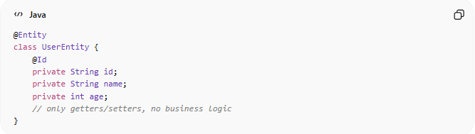
@Entity
class UserEntity {
@Id
private String id;
private String name;
private int age;
// only getters/setters, no business logic
}

🔄 Where It’s Used
# Source: AI Source: Provided by: [Data Path: Persons Table -> ID Column: 1, Name_En Column: Motasem Essam] -> From: [ChatGPT] on [1/23/2026]
- ORM frameworks (Hibernate, JPA, Entity Framework)
- Database CRUD operations
- Clean Architecture → Infrastructure Layer

⚠️ Common Mistakes
# Source: AI Source: Provided by: [Data Path: Persons Table -> ID Column: 1, Name_En Column: Motasem Essam] -> From: [ChatGPT] on [1/23/2026]
- Mixing domain logic inside persistence model ❌
- Using domain entity directly for DB ❌
- Not using mapping layer between Domain ↔ Persistence ❌

💡 Key Idea
# Source: AI Source: Provided by: [Data Path: Persons Table -> ID Column: 1, Name_En Column: Motasem Essam] -> From: [ChatGPT] on [1/23/2026]
Persistence Model = how the data is stored, not how the system behaves

🧾 Summary
# Source: AI Source: Provided by: [Data Path: Persons Table -> ID Column: 1, Name_En Column: Motasem Essam] -> From: [ChatGPT] on [1/23/2026]
- Maps Domain Entities to DB tables
- Contains fields + ORM annotations
- No business logic
- Works with mappers to convert to/from Domain Model

